Spring Boot Microservices 1
Traditionally we built monolitic apps. There may be one or more code bases but at the end of the day what gets deployed to the server will be one app. It runs on one server and it scales as a single entity. Note that on the coding side you can have many projects, you can have all the modularity but you will still end up one monolith deployed on the server.
With microservices this changes. You can still follow the same patterns with coding but what gets deployed and what happens at runtime is very different. This effects the way that we write code and deployment, also need to think what other challenges you might have.
In this course we will create a few microservices and have them communicate with eachother. You can do a whole lot of other things with microservices as well.
Some of the challenges:
- Where to start? Spring Cloud is just one way to create microservices. Just in Spring Cloud you have a lot of buzzwords, greek names etc.
- Lots of patterns
- Interdeoendent concepts
Why? Why there is this complexity, why do we have so many technologies involved. Because we have one big chuck of code which forms your application and you break them into smaller pieces. You are solving scalibility, modularity of deployment, meaning you can make changes to one portion of the application without having to redeploy the whole thing. So these are some of the advantages. But then you have a whole lot of new challenges you need to solve. Because you have this modularity you have to make sure your release process is fine. Because of the scalibility you have to make sure your microservices can scale and can have multiple copies and it will still work.
So you solve some problems but with those solutions comes new problems. One difference is that with monolith apps you have specific problems about your domain, but if you build it with microservices it becomes a more generic problem and this means that you can use frameworks, patterns and conventions to solve them more easily. You will have proven patterns and proven technologies no matter what application you are building.
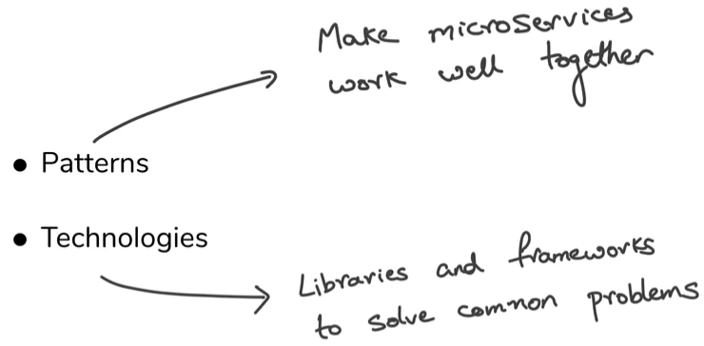
- Complexity hidden withing monolith vs complexity between microservices
Service discovery is a pattern which solves the question “how should small parts of your app communicate with each other?, how do you have them discover whom to communicate with?”
And you have technologies which allows to work with those patterns like EUREKA.

SOA vs Microservice
A lot of service oriented architecture (SOA) concepts are around creating the utilities like a ip discovery service. A soap endpoint where you give an ip and it returns the location. I don’t know where its gonna be used so let me create the service and keep it there and whoever wants to use it can use it. Similar concept -> web services
Microservices is not like that. You have an idea about what the application is and who will use the smaller parts. If you want to build an e-commerce app and you split your app into microservices, you know very well which part will use which microservice. Sometimes even a microservice can be used only by one other entity and that is completely fine. You are not intending it to be reused. Can it be reused? Yes, but not a requirement.
Movie Catalog API Application
In this course we will use Spring Cloud (one of the most robust way for building microservices). But there are a hundred different ways how you can build microservices.
We will build 3 microservices. 2 microservices which provides different kinds of data, the third will call those other 2 to get the data processes it and sends back a response. Generally you will see this kind of behaviour. Use lots of parts and then consolidate all the data and return back one response.
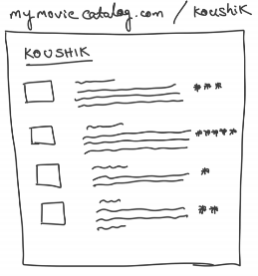
Lets imagine a js developer which wants an api from you. He is building a ui where you say example.com/userid and it will pull up all the movies this person watched and rated, movie name, description and rating. We will give back a response with a list with each element being the movie name, movie description and how the user rated it.
No database, no PUT, POST and DELETE.
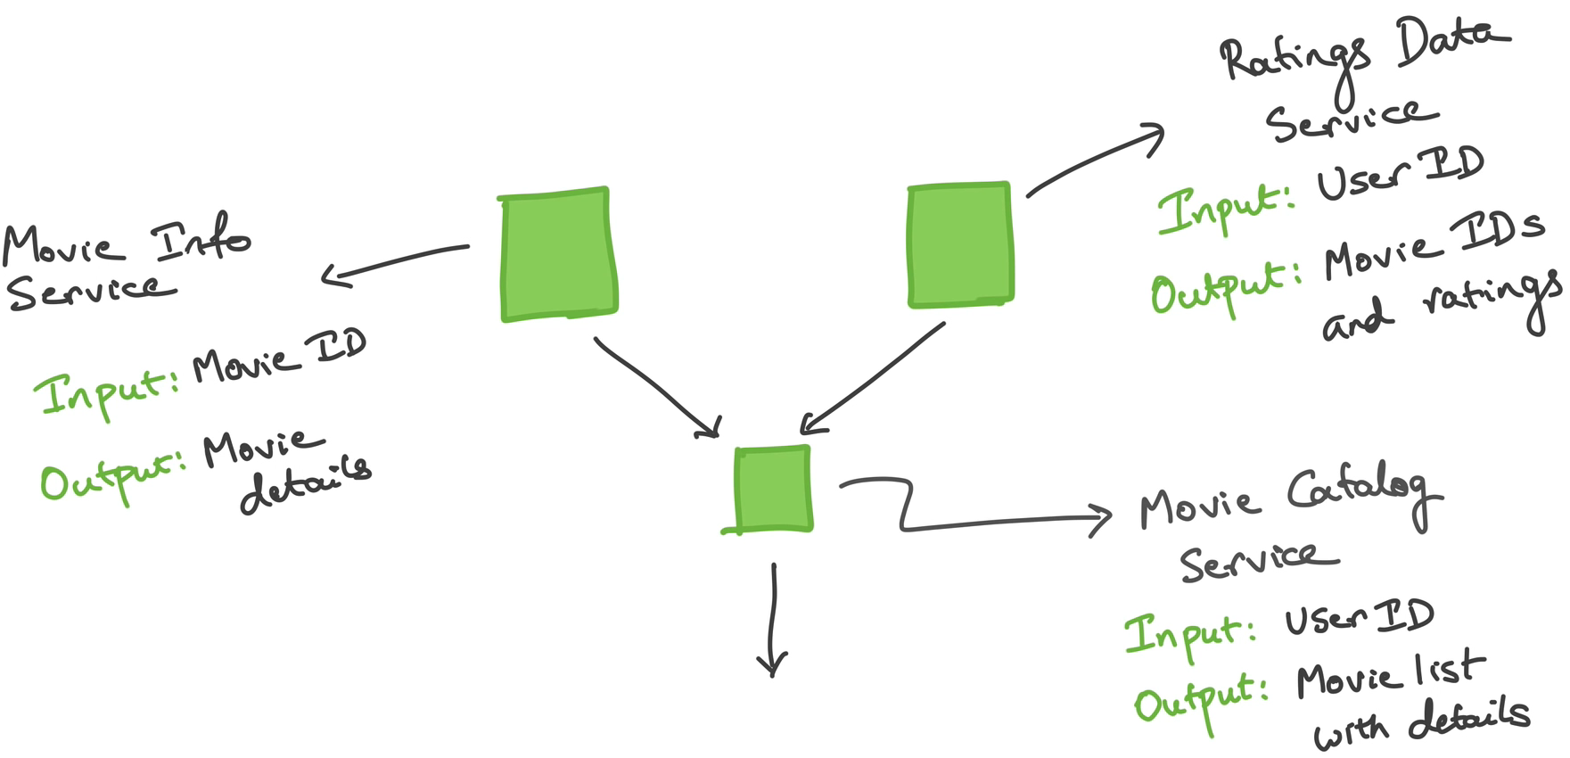

So first with the user id a call will go to ratings data service, to figure out what movies this guy watched and rated. After that, for each movie in the response it will make a call to the movie info service to get more information about the movie

- Create 3 Spring Boot projects. Each of these microservices will be a separate project.
- First we will build the movie catalog service API. After that the movie infor service API and lastly ratings data service API.
- Have movie catalog service call the other two services (the naive way)
- Implement a better way (Service discovery)
It is also possible for the clients to call individual microservices directly.
Not all microservices need to be Spring Boot applications. Since they will be communicating with REST, each microservice can be implemented with a different technology as long as it speaks REST. There are other technologies we could use. It a bit of preference but Spring makes it also easy.

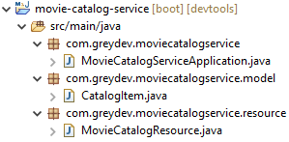
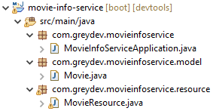
1. Create the 3 Services

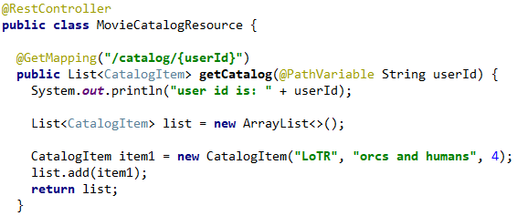
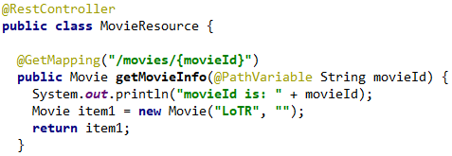

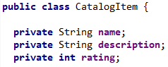
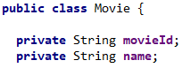

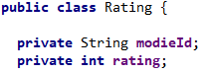
TODO: add last

Created 3 projects as described with STS -> New Spring Starter Project -> +Web Starter dependency (Spring MVC)

A common problem in development: Assigning ports to different microservices. Port 8080 is already taken. Need to give a different port. application.properties -> server.port=8081.
- In production you rarely have microservices running on the same machine, so the port for all apps could be 8080 since they will be deployed to different machines. Each spring project is running its own instance of tomcat.
- In production we would also run our application like this. We would start the jar file. If we need to configure tomcat for example, we can do that with the application.properties file as we just saw. We changed the port of the app which means configured tomcat.
- A good practice is to not run any application on 8080. Pick other ports, so if for some reason you will need 8080, you won’t need to configure anything. It saved lots of time for javabrains.
We use the ports 8081, 8082 and 8083 for our apps. Now started both projects in eclipse and they are working fine.

Creating a communcation channel between our projects
Now we will start with make the catalog and info services talk to eachother. This will be REST, so we will use a REST client library. Spring Boot comes with a client built in, its called RestTemplate. This is what we could use to make REST calls. But it is on its way of being deprecated! There is another way of doing it called WebClient.
RestTemplate is easier compared to WebClient. Because WebClient uses reactive programming. An asyncronus way of programming in java (RxJava), providing callback functions meaning “call this function when it is ready, I’m not going to wait for you” and you provide a lambda or function. RestTemplate is still widely used but WebClient his is the future.

